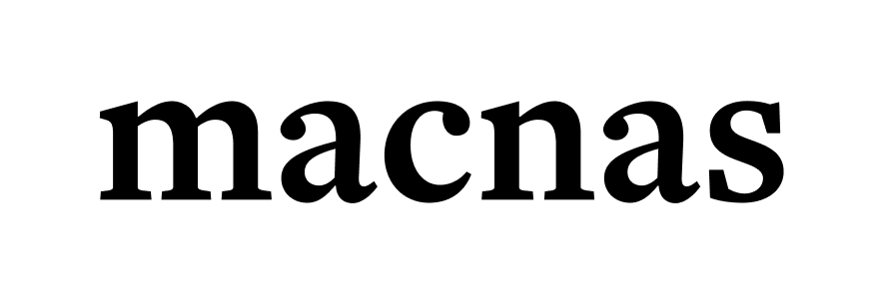

EQUALITY, DIVERSITY & INCLUSION POLICY

Macnas is committed to encouraging equality, diversity and inclusion within our organisation, and eliminating unlawful discrimination. The aim is for our company to be truly representative of all sections of society and our audience, and for each company member to feel respected and able to give their best.

DEFINITIONS

Equality
Equality seeks to advance equality of opportunity in access to employment, training, development, career opportunities etc., without any direct or indirect discrimination, or conscious or unconscious biases.

Equity
Equity is concerned with promoting fairness so that everyone starts from the same place. This may include positive measures in order to achieve greater equality of outcome.

Diversity
Diversity means more than just acknowledging and/or tolerating difference. Diversity involves understanding, appreciating and embracing differences and practicing mutual respect for qualities and experiences that are different from the majority.

Inclusion
Inclusion is a sense of belonging; feeling respected and valued; feeling a level of support and commitment from others so that one can achieve their best at work.

By embedding equality, diversity and inclusion into how we attract, invest in and retain employees, we create better organisational performance, stronger employee commitment and engagement, improved wellbeing and a culture of excellence.

To ensure that each person feels part of our community, Macnas's underpinning values driving the organisation are:

- Excellence, Integrity, Engagement, Diversity, Creativity

THE POLICY'S PURPOSE
This policy aims to:

- Provide equality, fairness and respect for all in our employment, whether temporary, part-time or full-time

- Oppose and avoid all forms of unlawful discrimination, including in pay and benefits, terms and conditions of employment, dealing with grievances and discipline, dismissal, redundancy, leave for parents, requests for flexible working, and selection for employment, promotion, training or other developmental opportunities

- Not unlawfully discriminate because of protected characteristics under the Employment Equality Acts 1998-2015, which include:

Protected Characteristics:
Gender (including gender identity): a person's gender identity including male, female, transgender or non-binary

Civil status: a person's civil status, be it single, married, separated, divorced, widowed, civil partnered or formerly civil partnered

Family status: being a parent of a person under 18 years or the resident primary carer or parent of a person with a disability

Socio-economic status: a combined economic and sociological measure of economic and social position in relation to others, based on the income, education and occupation of an individual and their family

Sexual orientation: a person's sexual orientation including gay, lesbian, bisexual and heterosexual

Religion: a person's religious belief, background, outlook or none

Age: a person's age (this does not apply to a person aged under 16)

Disability: includes people with physical, intellectual, learning, cognitive or emotional disabilities and a range of medical conditions

Race: includes race, skin colour, nationality or ethnic origin

Membership of the Traveller community: recognised as an ethnic group

ORGANISATIONAL COMMITMENTS
The organisation commits to:

- Encourage equality, diversity and inclusion in the workplace as they are good practice and make business sense

- Create a working environment free of bullying, harassment, victimisation and unlawful discrimination, promoting dignity and respect for all, and where individual differences and the contributions of all staff are recognised and valued

- Provide training to staff and all other company members about their rights and responsibilities under the EDI policy. Responsibilities include staff conducting themselves to help the organisation provide equal opportunities in employment, and prevent bullying, harassment, victimisation and unlawful discrimination

- Make opportunities for training, development and progress available to all staff, who will be helped and encouraged to develop their full potential, so their talents and resources can be fully utilised to maximise the efficiency of the organisation

- Ensure decisions concerning staff are based on merit (apart from any necessary and limited exemptions and exceptions allowed under the Equality Acts)

- Review employment practices and procedures when necessary to ensure fairness, and update them and the policy to take account of changes in the law

- Monitor the make-up of the workforce regarding information such as age, gender, ethnic background, sexual orientation, religion or belief and disability in encouraging equality, diversity and inclusion, and in meeting the aims and commitments set out in the policy

- Ensure all staff understand that they, as well as their employer, can be held liable for acts of bullying, harassment, victimisation and unlawful discrimination in the course of their work with Macnas, against fellow company members, customers, suppliers and the public

- Take seriously complaints of bullying, harassment, victimisation and unlawful discrimination by fellow employees, customers, suppliers, visitors, the public and any others in the course of the organisation's work activities. Such acts will be dealt with as misconduct under the organisation's grievance and/or disciplinary procedures, and appropriate action will be taken. Particularly serious complaints could amount to gross misconduct and lead to dismissal without notice. Additionally, sexual harassment may amount to both an employment rights matter and a criminal matter, as in the case of sexual assault allegations. In addition, harassment under the Employment Equality Acts 1998-2015 is a criminal offence when it relates to a protected characteristic

GOVERNANCE
The EDI policy is fully supported by Macnas Board of Directors and has been agreed with our senior company staff.

Details of the organisation's grievance and disciplinary procedures can be found at www.macnas.com, including who to contact to raise a grievance.

Use of the organisation's grievance and/or disciplinary procedures does not affect an employee's right to make a claim to an employment tribunal within three months of the alleged discrimination.

The organisation – in providing goods and/or services and/or facilities – is also committed against unlawful discrimination of stakeholders and the public.

ROLES AND RESPONSIBILITIES

All Company Members
All members of Macnas have a role under the Equality, Diversity and Inclusion Policy, in that they are responsible for their own behaviour but also responsible for ensuring that they carry out their role in line with this policy. Individuals therefore are:

- Responsible for making themselves aware of Macnas's Equality, Diversity and Inclusion Policy

- Expected to participate in training which supports the implementation of the company's Equality, Diversity and Inclusion Policy, as appropriate

- Responsible for their behaviour and expected to treat others with dignity and respect and to challenge inappropriate behaviour or discrimination

- Responsible for ensuring that their programmes of work, teaching content and resources demonstrate sensitivity to equality and diversity issues and are in compliance with the EDI Policy – non-compliance may result in complaints or potential disciplinary action

The Macnas Management team will ensure that:

- They take a leadership role in all Macnas equality, diversity and inclusion related matters

- They promote the Equality, Diversity and Inclusion policy

- There is strong leadership on equality, diversity and inclusion at all levels of the company

- In line with the Public Sector Duty, equality is promoted, discrimination prevented and the human rights of everyone affected by our policies and plans are protected

- Publicity and other materials reflect the diversity of Macnas's community

- External contractors are made aware of their responsibility in relation to equality and diversity and will be required to comply with Macnas's policies and regulations

- Public events are held, wherever possible, in accessible locations

- Set a good example by treating all members of the Macnas community with dignity and respect

- Manage unacceptable behaviour in accordance with relevant policies

- Increase awareness of EDI and promote a positive working, research, teaching, creative learning and social environment

Monitoring of this policy will include assessing how it and any supporting action plans are working in practice. The policy will be reviewed annually, with consideration given to addressing any issues identified.

This Policy will be reviewed in Dec 26.

